VISVESVARAYA TECHNOLOGICAL UNIVERSITY



A MINI PROJECT REPORT
on

GRAPHICS EDITOR
Submitted in partial fulfillment of the requirements
for the award of the degree of

Bachelor of Engineering
in

Computer Science Engineering
by

SAMHITHA K. V. - [1BG07CS088]

Under the guidance of

Prof. B.S. Umashankar

Professor, CS&E Department

BNM Institute of Technology


Vidyaya Amrutham Ashnuthe

Department of Computer Science & Engineering
B. N. M. Institute of Technology
12th Main, 27th Cross, Banashankari II Stage, Bangalore 560 070.
2010
B. N. M. Institute of Technology
12th Main, 27th Cross, Banashankari II Stage, Bangalore - 560070

Department of Computer Science & Engineering

Vidyaya Amrutham Ashnuthe

Certificate

Certified that the mini project work entitled GRAPHICS EDITOR carried out by Ms. SAMHITHA K. V. [1BG07CS088] bonafide student of B. N. M Institute of Technology in partial fulfillment for the award of Bachelor of Engineering in Computer Science & Engineering of the Visvesvaraya Technological University, Belgaum during the year 2010. It is certified that all corrections / suggestions indicated for Internal Assessment have been incorporated in the report deposited in the departmental library. The mini project report has been approved as it satisfies the academic requirements in respect of mini Project work prescribed for the said degree.

Dr. B.G. Prasad Prof. B.S. Uma Shankar,
Prof and HOD Professor, CS &E Dept
CS&E Dept

Name of the Examiners Signature with date

1.

2.

CONTENTS

- INTRODUCTION

- REQUIREMENT SPECIFICATION

- SYSTEM DESIGN

- IMPLEMENTATION

- TESTING

- RESULTS

- CONCLUSION and FUTURE ENHANCEMENTS

- BIBLIOGRAPHY

ACKNOWLEDGEMENT

I consider it a privilege to whole-heartedly express my gratitude and respect to each and everyone who guided and helped me in the successful completion of this project.
I am thankful to Prof. B. S. Umashankar, Department of Computer Science, for his co-operation and encouragement at all moments of my approach.
I am very thankful to the Director, Prof T. J. Ramamurthy and Principal, Dr. Udaykumar, for being kind enough to provide me an opportunity to work on a project in this institution.

I would also like to thank my parents and well wishers as well as my dear classmates for their guidance and co-operation.

Finally, it is a pleasure to have received a friendly co-operation by all the staff members of computer science department, BNMIT.

SAMHITHA K. V.

ABSTRACT

Graphics is in application in every part of the world and in most of the fields in the present day world.

Computer Graphics is concerned with all aspects of producing pictures or images using computer. It has a wide range of application starting from design of a product to simulation and animation.

This project is intended to design a Graphics package to implement the basic features of Microsoft Paint like,

- Drawing points.
- Drawing lines.
- Implementing pencil tool.
- Drawing polygons.
- Drawing circles.
- Creating wire frame models.
- Erasing the drawn figures.
- Writing Text.

And also some other features such as rotation, scaling and transformation.

This Graphics package uses a Graphics software system, OpenGL, which provides application program interface for various functions. The different functions are found in the ‘GL/glut.h’ header file.
This package also uses mouse, keyboard and icon driven functions to provide user interface.

INTRODUCTION
OpenGL is an open specification for an applications program interface for defining 2D and 3D objects. The specification is cross-language, cross-platform API for writing applications that produce 2D and 3D computer graphics. It renders 3D objects to the screen, providing the same
set of instructions on different computers and graphics adapters. Thus it allows us to write an application that can create the same effects in any operating system using any OpenGL-adhering graphics adapter.
Computer graphics, a 3-dimensional primitive can be anything from a single point to an n sided polygon. From the software standpoint, primitives utilize the basic 3-dimensional rasterization algorithms such as Bresenham's line drawing algorithm, polygon scan line fill, texture mapping and so forth. OpenGL's basic operation is to accept primitives such as points,
lines and polygons, and convert them into pixels. This is done by a graphics pipeline known as the OpenGL state machine. Most OpenGL commands either issue primitives to the graphics
pipeline, or configure how the pipeline processes these primitives.
OpenGL is a low-level, procedural API, requiring the programmer to dictate the exact steps
required to render a scene. OpenGL's low-level design requires programmers to have a good
knowledge of the graphics pipeline, but also gives a certain amount of freedom to implement
novel rendering algorithms.

Advantages of OpenGL :
- with different 3D accelerators, by presenting the programmer To hide the complexities of
interfacing with a single, uniform API.
-  To hide the differing capabilities of hardware platforms, by requiring that all
implementations support the full OpenGL feature set (using software emulation if necessary).

About Microsoft Visual Studio 2008 Professional Edition :
Visual Studio 2008 delivers on Microsoft’s vision of smart client applications by letting developers
quickly create connected applications that deliver the highest quality rich user experiences. This new version lets any size organization create more secure, more manageable, and more reliable applications that take advantage of Windows Vista, 2007 Office System and the Web. By building these new types of applications, organizations will find it easier than ever to capture and analyze information so that they can make effective business decisions.

INTRODUCTION ON OPENGL
OpenGL provides the programmer with an interface to graphics hardware. It is a powerful,
low-level rendering and modeling software library, available on all major platforms, with wide
hardware support. It is designed for use in any graphics applications, from games to modeling to CAD OpenGL intentionally provides only low-level rendering routines, allowing the programmer a great deal of control and flexibility. The provided routines can easily be used to build high-level rendering and modeling libraries, and in fact, the OpenGL Utility Library (GLU), which is included in most OpenGL distributions, does exactly that. Note also that OpenGL is just a graphics library; unlike DirectX, it does not include support for sound, input, networking, or anything else not directly related to graphics.

OpenGL Architecture

OpenGL is a collection of several hundred functions providing access to all the features
offered by your graphics hardware. Internally, it acts as a state machine--a collection of states
that tell OpenGL what to do. Using the API, you can set various aspects of the state machine,
including such things as the current color, lighting, blending, and so on. When rendering,
everything drawn is affected by the current settings of the state machine. It's important to be
aware of what the various states are, and the effect they have, because it's not uncommon to have unexpected results due to having one or more states set incorrectly.
At the core of OpenGL is the rendering pipeline, as shown in Figure 2.1. You don't need to
understand everything that happens in the pipeline at this point, but you should at least be aware
that what you see on the screen results from a series of steps. Fortunately, OpenGL handles most of these steps for you.

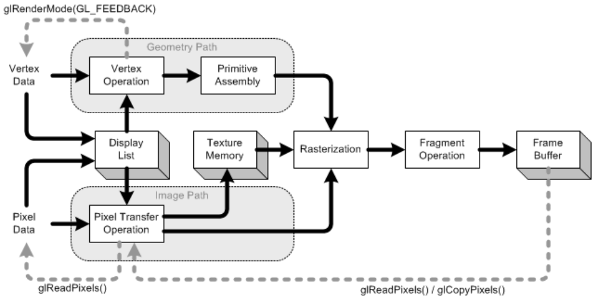
Fig 2.1 The OpenGL rendering pipeline.

GLUT
GLUT, short for OpenGL Utility Toolkit, is a set of support libraries available on every major
platform. OpenGL does not directly support any form of windowing, menus, or input. That's
where GLUT comes in. It provides basic functionality in all of those areas, while remaining
platform independent, so that you can easily move GLUT-based applications from, for example,
Windows to UNIX with few, if any, changes.
GLUT is easy to use and learn, and although it does not provide you with all the functionality
the operating system offers, it works quite well for demos and simple applications.

REQUIREMENTS SPECIFICATION

HARDWARE REQUIREMENTS

Processor -- Pentium 3 or higher
RAM -- 512MB or more
Hard disk -- 80GB or more
Monitor -- EGVGA compatible
Keyboard -- Standard 101 key keyboard
Backup Media -- hard disk / CD / DVD
Mouse -- 2 or 3 button mouse

SOFTWARE REQUIREMENTS

Operating System -- Windows 98 or higher, Windows XP with DOS
environment.
Language Tool -- C
Compiler -- Visual C++
Libraries -- Supporting glut.h and 16 bit color resolution.
Documentation Tools -- Microsoft Word, Microsoft Paint

SYSTEM DESIGN
Platform
The package is implemented using Microsoft Visual C++, under the Windows platform. OpenGL and associated toolkits are used for the package development.

Data structures
Package uses data structures like array for storing the co-ordinates of primitives and also other information.
BUILT IN FUNCTIONS

1. glBegin and glEnd - delimit the vertices of a primitive or a group of like primitives

C Specification

void glBegin ( GLenum mode);

void glEnd();

Parameters
mode - Specifies the primitive or primitives that will be created from vertices presented between glBegin and the subsequent glEnd.
Ten symbolic constants accepted are
GL_POINTS GL_TRIANGLE_STRIP
GL_LINES GL_TRIANGLE_FAN
GL_LINE_STRIP GL_QUADS
GL_LINE_LOOP GL_QUAD_STRIP
GL_TRIANGLES GL_POLYGON

Description
glBegin and glEnd delimit the vertices that define a primitive or a group of like primitives. glBegin accepts a single argument that specifies in which of ten ways the vertices are interpreted. Taking n as an integer count starting at one, and N as the total number of vertices specified, the interpretations are as follows:
GL_POINTS
Treats each vertex as a single point. Vertex n defines point n. N points are drawn.
GL_LINES
Treats each pair of vertices as an independent line segment. Vertices 2n−1 and 2n define line n. N/2 lines are drawn.
GL_LINE_STRIP
Will draw a connected group of line segments from the first vertex to the last. Vertices n and n+1 define line n. N−1 lines are drawn.
GL_LINE_LOOP
Will draw a connected group of line segments from the first vertex to the last, then back to the first. Vertices n and n+1 define line n. The last line, however, is defined by vertices N and 1. N lines are drawn.
GL_TRIANGLES
Treats each triplet of vertices as an independent triangle. Vertices 3n−2, 3n−1, and 3n define triangle n. N/3 triangles are drawn.
GL_TRIANGLE_STRIP
Will draw a connected group of triangles. One triangle is defined for each vertex presented after the first two vertices. For odd n, vertices n, n+1, and n+2 define triangle n. For even n, vertices n+1, n, and n+2 define triangle n. N−2 triangles are drawn.
GL_TRIANGLE_FAN
Will draw a connected group of triangles. One triangle is defined for each vertex presented after the first two vertices. Vertices 1, n+1, and n+2 define triangle n. N−2 triangles are drawn.
GL_QUADS
Treats each group of four vertices as an independent quadrilateral. Vertices 4n−3, 4n−2, 4n−1, and 4n define quadrilateral n. N/4 quadrilaterals are drawn.
GL_QUAD_STRIP
Will draw a connected group of quadrilaterals. One quadrilateral is defined for each pair of vertices presented after the first pair. Vertices 2n−1, 2n, 2n+2, and 2n+1 define quadrilateral n. N/2−1 quadrilaterals are drawn. Note that the order in which vertices are used to construct a quadrilateral from strip data is different from that used with independent data.
GL_POLYGON
It will draw a single, convex polygon. Vertices 1 through N define this polygon.
Only a subset of GL commands can be used between glBegin and glEnd. The commands are glVertex, glColor, glIndex, glNormal etc.. Also, it is acceptable to use glCallList or glCallLists to execute display lists that include only the preceding commands. If any other GL command is executed between glBegin and glEnd, the error flag is set and the command is ignored.

2. glClearColor — specify clear values for the color buffers.

C Specification

glClearColor ( GLclampf red, GLclampf green, GLclampf blue, GLclampf alpha );

Parameters
red , green , blue , alpha
Specify the red, green, blue, and alpha values used when the color buffers are cleared. The initial values are all 0.

Description
glClearColor specifies the red, green, blue, and alpha values used by glClear to clear the color buffers. Values specified by glClearColor are clamped to the range [0, 1]

3. glClear - clears buffers to preset values.

C Specification

glClear( GLbitfield mask );

Parameters
mask Bitwise OR of masks that indicate the buffers to be cleared. The two masks are GL_COLOR_BUFFER_BIT, and GL_DEPTH_BUFFER_BIT.

Description

glClear takes a single argument that is the bitwise OR of several values indicating which buffer is to be cleared.
The values are as follows:
GL_COLOR_BUFFER_BIT
Indicates the buffers currently enabled for color writing.
GL_DEPTH_BUFFER_BIT
Indicates the depth buffer.

4. glEnable and glDisable — enable or disable server-side GL capabilities

C Specification

glEnable ( GLenum cap );

glDisable ( GLenum cap );

Parameters
cap Specifies a symbolic constant indicating a GL capability.

Description
glEnable and glDisable enable and disable various capabilities. We use glIsEnabled or glGet to determine the current setting of any capability.

5. glFlush — force execution of GL commands in finite time

C Specification

glFlush();

Description
Different GL implementations buffer commands in several different locations, including network buffers and the graphics accelerator itself. glFlush empties all of these buffers, causing all issued commands to be executed as quickly as they are accepted by the actual rendering engine. Though this execution may not be completed in any particular time period, it does complete in finite time.
Because any GL program might be executed over a network, or on an accelerator that buffers commands, all programs should call glFlush whenever they count on having all of their previously issued commands completed. For example, call glFlush before waiting for user input that depends on the generated image.

6. glLoadIdentity() — replace the current matrix with the identity matrix

C Specification

void glLoadIdentity();
Description
glLoadIdentity replaces the current matrix with the identity matrix. It is semantically equivalent to calling glLoadMatrix with the identity matrix but in some cases it is more efficient

7. glMatrixMode — specify which matrix is the current matrix

C Specification

glMatrixMode ( GLenum mode );

Parameters
mode Specifies which matrix stack is the target for subsequent matrix operations. Three values are accepted:GL_MODELVIEW, GL_PROJECTION, and GL_TEXTURE. The initial value is GL_MODELVIEW.

Description
glMatrixMode sets the current matrix mode and Applies subsequent matrix operations to the matrix stack set by mode.

8. glPointSize — specify the diameter of rasterized points

C Specification

glPointSize ( GLfloat size );

Parameters
size Specifies the diameter of rasterized points. The initial value is 1.

9. glViewport — set the viewport

C Specification

glViewport (Glint x , GLint y , GLsizei width , GLsizei height);

Parameters
x , y Specify the lower left corner of the viewport rectangle, in pixels. The initial value is (0,0) .
width , height Specify the width and height of the viewport. When a GL context is first attached to a window, width and height are set to the dimensions of that window.

Description
glViewport specifies the affine transformation of x and y from normalized device coordinates to window coordinates. Let (x_{nd},y_{nd}) be normalized device coordinates.
Viewport width and height are silently clamped to a range that depends on the implementation. To query this range we call glGet with argument GL_MAX_VIEWPORT_DIMS.

10. gluOrtho2D — define a 2D orthographic projection matrix

C Specification

gluOrtho2D ( GLdouble left,GLdouble right,GLdouble bottom, GLdouble top );

Parameters
left, right - Specify the coordinates for the left and right vertical clipping planes.
bottom, top Specify the coordinates for the bottom and top horizontal clipping planes.

Description
gluOrtho2D sets up a two-dimensional orthographic viewing region. This is equivalent to calling glOrtho with near=-1 and far=1.

11. glutBitmapCharacter — renders a bitmap character using OpenGL.

C Specification

glutBitmapCharacter ( void *font, int character );

Parameters
font - Bitmap font to use.
character - Character to render (not confined to 8 bits).

12. glutCreateWindow — creates a top-level window.

C Specification

glutCreateWindow ( char *name );
Parameters
name - ASCII character string for use as window name.

Description
glutCreateWindow creates a top-level window. The name will be provided to the window system as the window's name. The intent is that the window system will label the window with the name.
Implicitly, the current window is set to the newly created window.
The display state of a window is initially for the window to be shown. But the window's display state is not actually acted upon until glutMainLoop is entered. This means until glutMainLoop is called, rendering to a created window is ineffective because the window can not yet be displayed

13. glutDisplayFunc — sets the display callback for the current window.

C Specification

glutDisplayFunc ( void (*func)(void));
Parameters
func - The new display callback function.

Description
glutDisplayFunc sets the display callback for the current window. When GLUT determines that the normal plane for the window needs to be redisplayed, the display callback for the window is called. Before the callback, the current window is set to the window needing to be redisplayed and the layer in use is set to the normal plane. The display callback is called with no parameters. The entire normal plane region should be redisplayed in response to the callback.
GLUT determines when the display callback should be triggered based on the window's redisplay state. The redisplay state for a window can be either set explicitly by calling glutPostRedisplay or implicitly as the result of window damage reported by the window system. Multiple posted redisplays for a window are coalesced by GLUT to minimize the number of display callbacks called.

14. glutInit — initialize the GLUT library.

C Specification

glutInit ( int *argcp, char ** argv );

Parameters
argcp - A pointer to the program's unmodified argc variable from main. Upon return, the value pointed to by argcp will be updated, because glutInit extracts any command line options intended for the GLUT library.
argv - The program's unmodified argv variable from main. Like argcp, the data for argv will be updated because glutInit extracts any command line options understood by the GLUT library.

Description
glutInit will initialize the GLUT library and negotiate a session with the window system. During this process, glutInit may cause the termination of the GLUT program with an error message to the user if GLUT cannot be properly initialized.
15. glutIdleFunc — sets the global idle callback.

C Specification

glutIdleFunc ( void (*func)() );
Parameters
func - The new idle callback function.

Description
glutIdleFunc sets the global idle callback to be function so that a GLUT program can perform background processing tasks or continuous animation when window system events are not being received. If enabled, the idle callback is continuously called when events are not being received. The callback routine has no parameters. The current window and current menu will not be changed before the idle callback. Programs with multiple windows and/or menus should explicitly set the current window and/or current menu and not rely on its current setting.
The amount of computation and rendering done in an idle callback should be minimized to avoid affecting the program's interactive response. In general, not more than a single frame of rendering should be done in an idle callback.

16. glutInitDisplayMode — sets the initial display mode.

C Specification

glutInitDisplayMode ( unsigned int mode );
Parameters
mode - Display mode, normally the bitwise OR-ing of GLUT display mode bit masks. See values below:
GLUT_RGB - Bit mask to select the Red, Green and Blue color mode.
GLUT_SINGLE - Bit mask to select a single buffered window. This is the default if neither GLUT_DOUBLE or GLUT_SINGLE are specified.
GLUT_DOUBLE - Bit mask to select a double buffered window. This overrides GLUT_SINGLE if it is also specified.
GLUT_DEPTH - Bit mask to request a window with a depth buffer.

17. glutKeyboardFunc — sets the keyboard callback for the current window.

C Specification

glutKeyboardFunc(void (*func)(unsigned char key, int x, int y) );
Parameters
func - The new keyboard callback function.
Description
glutKeyboardFunc sets the keyboard callback for the current window. When a user types into the window, each key press generating an ASCII character will generate a keyboard callback. The key callback parameter is the generated ASCII character. The state of modifier keys such as Shift cannot be determined directly; their only effect will be on the returned ASCII data. The x and y callback parameters indicate the mouse location in window relative coordinates when the key was pressed. When a new window is created, no keyboard callback is initially registered, and ASCII key strokes in the window are ignored.

18. glutMainLoop — enters the GLUT event processing loop.

C Specification

void glutMainLoop ( );
Description
glutMainLoop enters the GLUT event processing loop. This routine should be called at most once in a GLUT program. Once called, this routine will never return. It will call as necessary any callbacks that have been registered

19. glutMouseFunc — sets the mouse callback for the current window.

C Specification

glutMouseFunc(void (*func)(int button, int state, int x, int y));

Parameters
func - The new mouse callback function.

Description
glutMouseFunc sets the mouse callback for the current window. When a user presses and releases mouse buttons in the window, each press and each release generates a mouse callback. The button parameter is one of GLUT_LEFT_BUTTON, GLUT_MIDDLE_BUTTON, or GLUT_RIGHT_BUTTON. For systems with only two mouse buttons, it may not be possible to generate GLUT_MIDDLE_BUTTON callback. For systems with a single mouse button, it may be possible to generate only a GLUT_LEFT_BUTTON callback. The state parameter is either GLUT_UP or GLUT_DOWN indicating whether the callback was due to a release or press respectively. The x and y callback parameters indicate the window relative coordinates when the mouse button state changed. If a GLUT_DOWN callback for a specific button is triggered, the program can assume a GLUT_UP callback for the same button will be generated (assuming the window still has a mouse callback registered) when the mouse button is released even if the mouse has moved outside the window.
If a menu is attached to a button for a window, mouse callbacks will not be generated for that button.

20. glutMotionFunc — set the motion and passive motion callbacks respectively for the current window.

C Specification

glutMotionFunc ( void (*func)(int x, int y));
Parameters
func - The new motion or passive motion callback function.

Description
glutMotionFunc set the motion callback for the current window. The motion callback for a window is called when the mouse moves within the window while one or more mouse buttons are pressed. The x and y callback parameters indicate the mouse location in window relative coordinates.

21. glutPostRedisplay — marks the current or specified window as needing to be redisplayed.

C Specification

glutPostRedisplay ( );
Description
glutPostRedisplay marks the normal plane of current window as needing to be redisplayed. After the call, the next iteration through glutMainLoop, the window's display callback will be called to redisplay the window's normal plane. Multiple calls to glutPostRedisplay before the next display callback opportunity generates only a single redisplay callback. glutPostRedisplay may be called within a window's display or overlay display callback to re-mark that window for redisplay.

22. glutReshapeFunc — sets the reshape callback for the current window.

C Specification

glutReshapeFunc (void (*func)(int width, int height));

Parameters
func - The new reshape callback function.

Description
glutReshapeFunc sets the reshape callback for the current window. The reshape callback is triggered when a window is reshaped. A reshape callback is also triggered immediately before a window's first display callback after a window is created or whenever an overlay for the window is established. The width and height parameters of the callback specify the new window size in pixels. Before the callback, the current window is set to the window that has been reshaped.
23. glLineStipple - specify the line stipple pattern
C Specification
void glLineStipple( GLint factor,GLushort pattern );
Parameters
factor - Specifies a multiplier for each bit in the line stipple pattern. If factor is 3, for example, each bit in the pattern is used three times before the next bit in the pattern is used. factor is clamped to the range [1, 256] and defaults to 1.
pattern - Specifies a 16-bit integer whose bit pattern determines which fragments of a line will be drawn when the line is rasterized. Bit zero is used first; the default pattern is all 1's.

24. glLineWidth - specify the width of rasterized lines

C Specification
void glLineWidth(GLfloat width)

Parameters
width - Specifies the width of rasterized lines. The initial value is 1.

25. glRotatef The rotation of an object by an angle is accomplished by rotating each of the points of the object about the x axis, y axis or z axis. vx, vy and vz take the value 1 of the object is to be rotated about them. The rotated points can be obtained using the OpenGL functions.
C Specification
glRotatef ( angle, vx ,vy ,vz );
26. glScalef
The scaling operation on an object can be carried out by multiplying each of the points (x,y) by the scaling factors sx, sy and sz.

C Specification
glScalef ( sx, sy, sz );
27. glTranslatef
The translation operation on an object can be carried out by adding to each of the points (x,y), the translating factors dx, dy and dz.

C Specification
glTranslatef ( dx, dy, dz );

IMPLEMENTATION
USER INTERFACE
The working window is designed to have icons on the left side and top from which the user can choose the action he wants to perform. The icon chosen is highlighted and the sub-options of the chosen icon is displayed at the top.
COLOR PALLETE

Color palette is provided at the top right corner of the window. It is designed using the number of color buttons. The color button click sets the color of the drawing ink to the respective color.
Each color button is displayed in different color using the color values specified in Color
array.

2D DRAWING

2D drawings are done in the main window. The type of 2D drawing is set by the icon click of the user. The different options provided are,

PENCIL

The first point we click will be the starting point of the pencil tool. The drawing will end only when the user releases the mouse button. The mouse motion by the user with the mouse left button pressed is detected and lines are drawn.

BRUSH / PAINT

Brush is similar to pencil but it has different thickness and different brush shapes. This provides the user to shade his drawing effectively.

RECTANGLE

Plain Rectangle
The plain rectangle is implemented using rubber band technique. The rectangle is drawn from the initial point to the current mouse point using Logical Operations function.

Filled Rectangle
Rectangle is similar to plain rectangle but the object is drawn using POLYGON.

CIRCLE

Plain Circle
Circle drawing is done by using midpoint circle drawing algorithm. First click will be the
midpoint and the distance between the first click point to the next mouse position, with the mouse left button clicked, is the radius of the circle.

Filled Circle
Filled circle is implemented using the midpoint circle drawing algorithm. But the circle is
filled by drawing triangles from the center to each consecutive pixel on the border.

LINE

Line is implemented using rubber band technique. The first point is the initial point and the next point will be continuously changing until the user releases the mouse button.

TEXT

Text is implemented using the keyboard function. The click position will be the position of the text. Whenever a key is pressed it is instantaneously displayed on the screen. The font used is GLUT_BITMAP_9_BY_15.

SPRAY

Spray will take the click position as the center pixel position and draws points specified at the time of design on the window. This is also done on the movement of mouse with its left button pressed.

POLYGON

Plain Polygon
Polygon is drawn by selecting the points. For each mouse click the lines are drawn using LINE_STRIP.

Filled Polygon
It follows the same technique as the plain polygon but stores the mouse clicks in an array and then draws a polygon considering those points.

SPIRAL

The spiral is implemented by using basic spiral drawing function. The intial mouse click will be considered as the mid point and the second click gives the radius.

ERASER

The Eraser is implemented by using the benefit of mouse motion function. The click
area will be patched with the black rectangle of eraser size.
Different eraser sizes are provided for the user to choose among.

SIZE

The user can also choose the size of lines that he wants to work with. There are three different sizes provided.

LINE STIPPLE

These options appear on the click of the line icon. The options provide the user to choose from plain, dotted and dashed lines.

CLEAR SCREEN

This option clears the working area of the window and provides a blank window.

THE GRAPHICS LIBRARY
The OpenGL provides a lot of functions and routines for the drawing of graphics primitives and for doing graphics operations.
The application package is designed to access OpenGL directly through functions in three libraries. Functions in main GL library have names that begin with letters ‘gl’ and are stored in a library usually referred to as GL. The second is the Open GL Utility Library(GLU). The functions that belong to this library start from ‘glu’. This library uses only GL functions, but contains code for creating common objects and simplify viewing.

TESTING

BASIC FUNCTIONS
FUNCTION NAME | INPUT | OUTPUT
LINE | Mouse click and point of release of the mouse button clicked | Line between the two points. Rubber banding effect on mouse movement.
PENCIL | Mouse click and drag | Series of lines from the point of click
PLAIN RECTANGLE | Two points(diagonal ends) Point of initial mouse click and point of release | The boundary of the rectangle is drawn
FILLED RECTANGLE | Two points(diagonal ends) Point of initial mouse click and point of release | A filled rectangle is drawn
PLAIN POLYGON | Takes series of mouse click points from the user | The boundary of the polygon connecting those points in the order of click is drawn
FILLED POLYGON | Takes series of mouse click points from the user | A filled polygon connecting those points in the order of click is drawn
PLAIN CIRCLE | Initial mouse click is considered as the centre an mouse motion gives the radius | The circumference of the circle is drawn with radius as the distance between the mouse click and release
FILLED CIRCLE | Initial mouse click is considered as the centre an mouse motion gives the radius | A filled circle is drawn similar to the plain circle.
TEXT | The press of keyboard keys is considered as input | The keys pressed are displayed starting from the mouse click position.
ERASER | Choose the eraser icon and drag on the working window | Erases the dragged portion on the drawing screen.
CLEAR SCREEN | Choose the clear screen icon | Clears the screen

GENERAL FUNCTIONS
LINE STYLES | Sub icons for plain, dotted and dashed lines |  | The line type is selected to be that of the chosen option
LINE THICKNESS | Sub icons for selection of size. A user click selects the desired option |  | The objects are drawn with the specified thickness.
ERASER OPTIONS |  | Choose the eraser option from the sub icons and drag in the working window. | Erases the dragged portion on the drawing screen with the eraser of the chosen size..
COLOR PALLETE | Choose a color from the color icons |  | An object is drawn with the specified color.
PAINT | Choose a particular fill color in the color icons |  | The mouse drag will fill color in desired locations with the color selected

SPECIAL FUNCTIONS
PAINT BRUSH TYPE | The desired brush shape is selected from the sub icons | The mouse drag locations are painted with the desired color and shape of brush.
SPIRAL | The first mouse click is taken as centre and the distance between the first and second is the radius | A spiral will be drawn with the specified radius.
TRANSFORMATIONS | The object last drawn is subjected to the specified transformation. | The object is transformed.

DIFFERENT TYPES OF TESTING
Unit Testing
Individual components are tested to ensure that they operate correctly. Each component is tested independently, without other system components.

Module Testing
A module is a collection of dependent components such as a object class, an abstract data type or some looser collection of procedures and functions. A module related components, so can be tested without other system modules.

System Testing
This is concerned with finding errors that result from unanticipated interaction between sub-system interface problems.

Acceptance Testing
The system is tested with data supplied by the system customer rather than simulated test data.

CONCLUSION

I had a great experience in the course of designing this package, which made me discover and learn many things as pertaining to the topic of OpenGL programming. I have tried, to my best potential, to incorporate all the basic level requirements of a normal graphics package for Windows operating system.
This is a very reliable graphics package supporting various objects like circle, rectangle, any kind of polygon and many more. It also provides color selection, icon based user friendly interface.
This project meets all the basic requirements of a user, successfully. Since it is user friendly, it enables the user to interact effectively and easily.
This package has been implemented using optimized algorithms and thus is fast. Special attention has been provided to the interface, icons and sub icons that make its use comfortable. I hope this package proves to be flexible in all aspects to one and all.

Maintenance & Future Enhancements
- Options to undo and redo changes in the working area can be added.
- Option for saving the current drawing can be provided.
- More features like ellipse and curves can be added.

BIBLIOGRAPHY

Books having C/C++ graphics as chapters have been used as a reference in this project.
1] Interactive computer graphics – A top-down approach using OpenGL by Edward Angel

2] Computer Graphics by Zhigang Xiang and Roy A Plastock.

Websites
www.enggresources.com

SNAP SHOTS
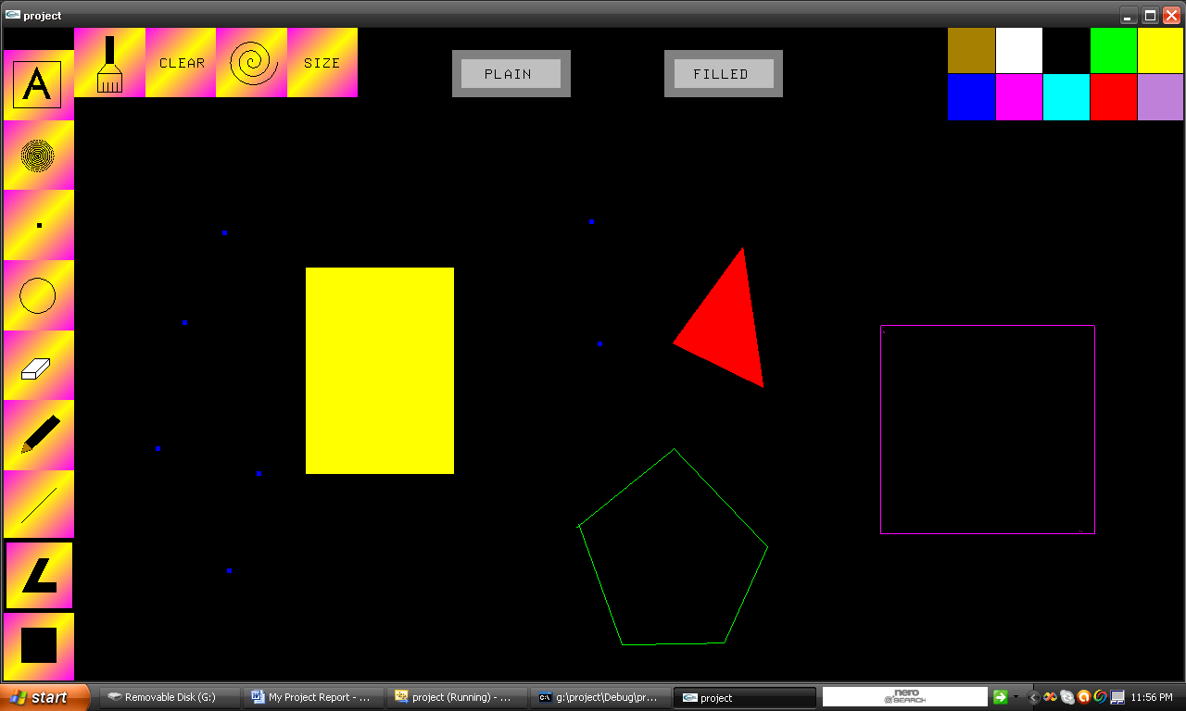
Snap shot showing the use of Rectangle, Polygon and Point functions.
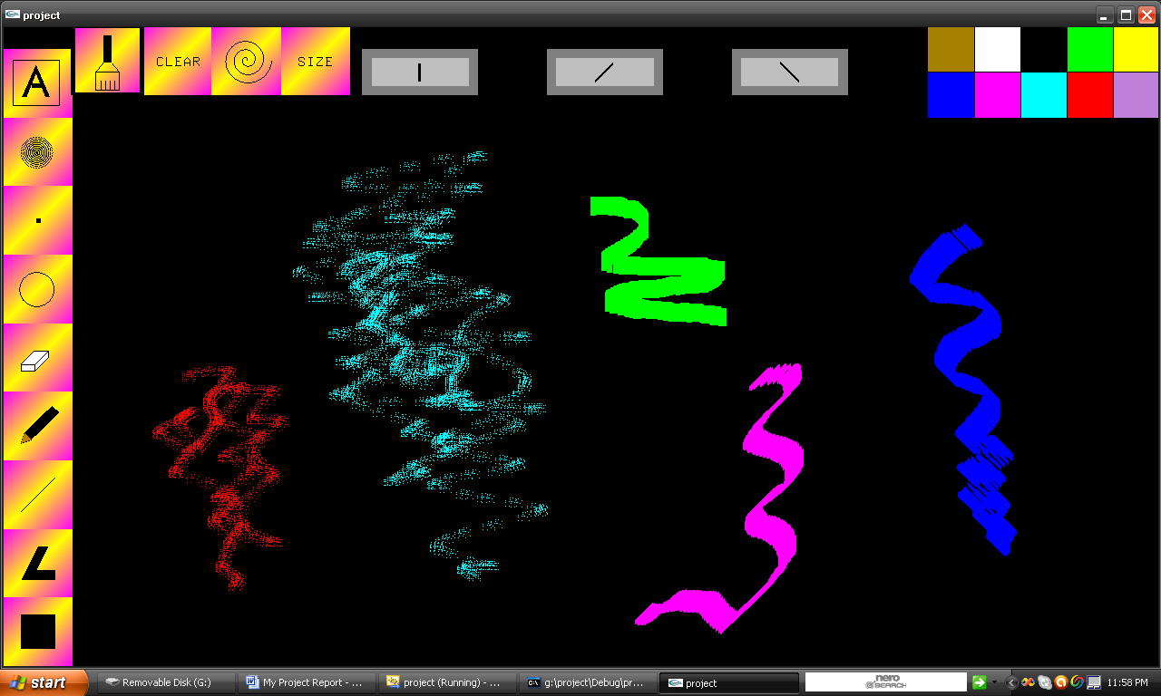
Snap shot showing the use of Spray and Paint functions.
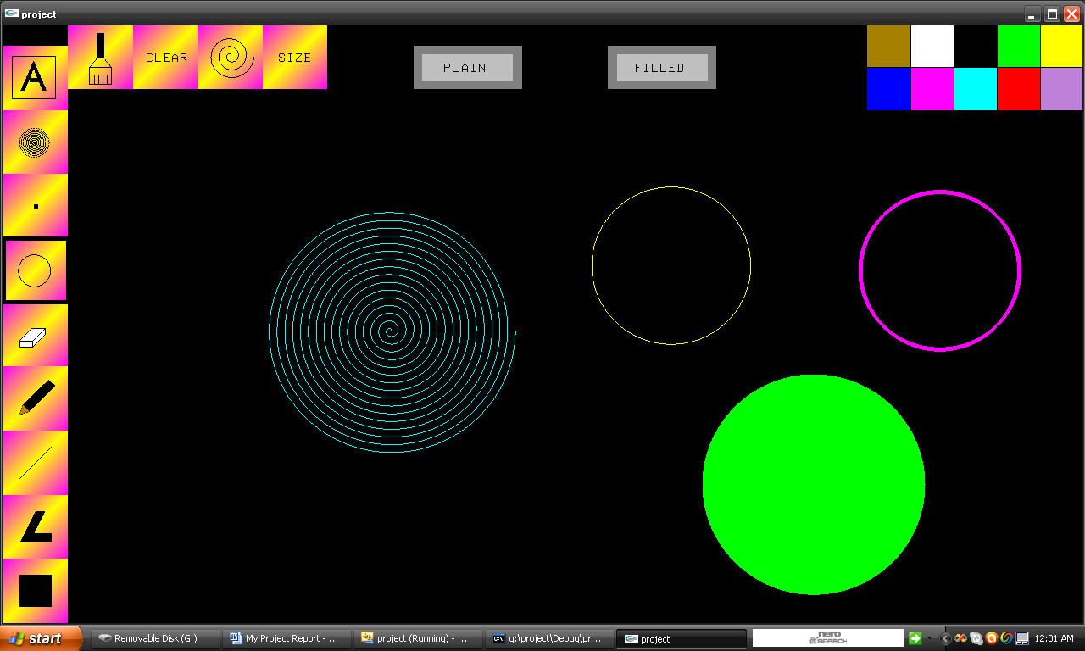
Snap shot showing the use of circle and spiral tools

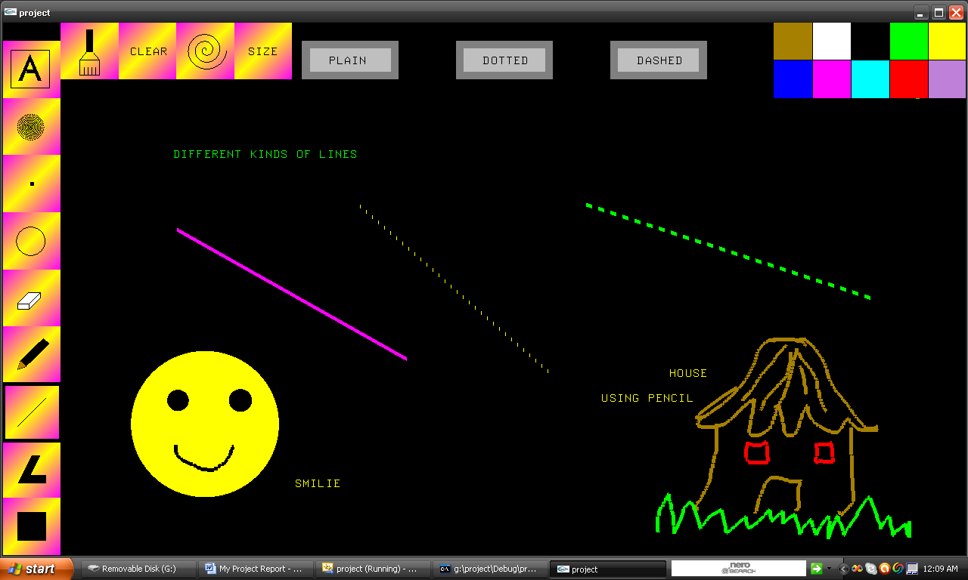
Snap shot showing the use of line and pencil tools.

